**Pong Game**

OOP Project

Deadline: 30th November 2022

**Instructions:**

* Only and only 2 group members are allowed
* The history of players and their last highest score should be kept in files. For that you may have to modify the given UML diagram
* One player (vs computer) and 2 players options should be given
* *In case of Plagiarism a second chance will not be given and F will be awarded even before the final exams.*

## 

## About Pong

Pong is one of the first computer games that ever created, this simple "tennis like" game features two paddles and a ball, the goal is to defeat your opponent by being the first one to gain10 point, a player gets a point once the opponent misses a ball. The game can be played with two human players, or one player against a computer controlled paddle. The game was originally developed by Allan Alcorn and released in 1972 by Atari corporations. Soon, Pong became a huge success, and became the first commercially successful game, on 1975, Atari release a home edition of Pong (the first version was played on Arcade machines) which sold 150,000 units. Today, the Pong Game is considered to be the game which started the video games industry, as it proved that the video games market can produce significant revenues.

## What you need to know:

1. How Pong works
2. C++ programming language and OOP concepts
3. Libraries for:
   1. Crating a Window or Client area
   2. Drawing shapes to client area
   3. Detecting keyboard/mouse input
   4. Play sounds/music
4. Graphics and GUIs
5. Time and creativity

In the grand scheme of things, *Pong* isn’t too complicated, neither playing it or architecturing it. Here’s a UML diagram, for initial guidelines, that covers how the classes within the game code are going to work. You may need to modify the given UML diagram and for that you are allowed to add additional functionalities but you can’t reduce the requirements.

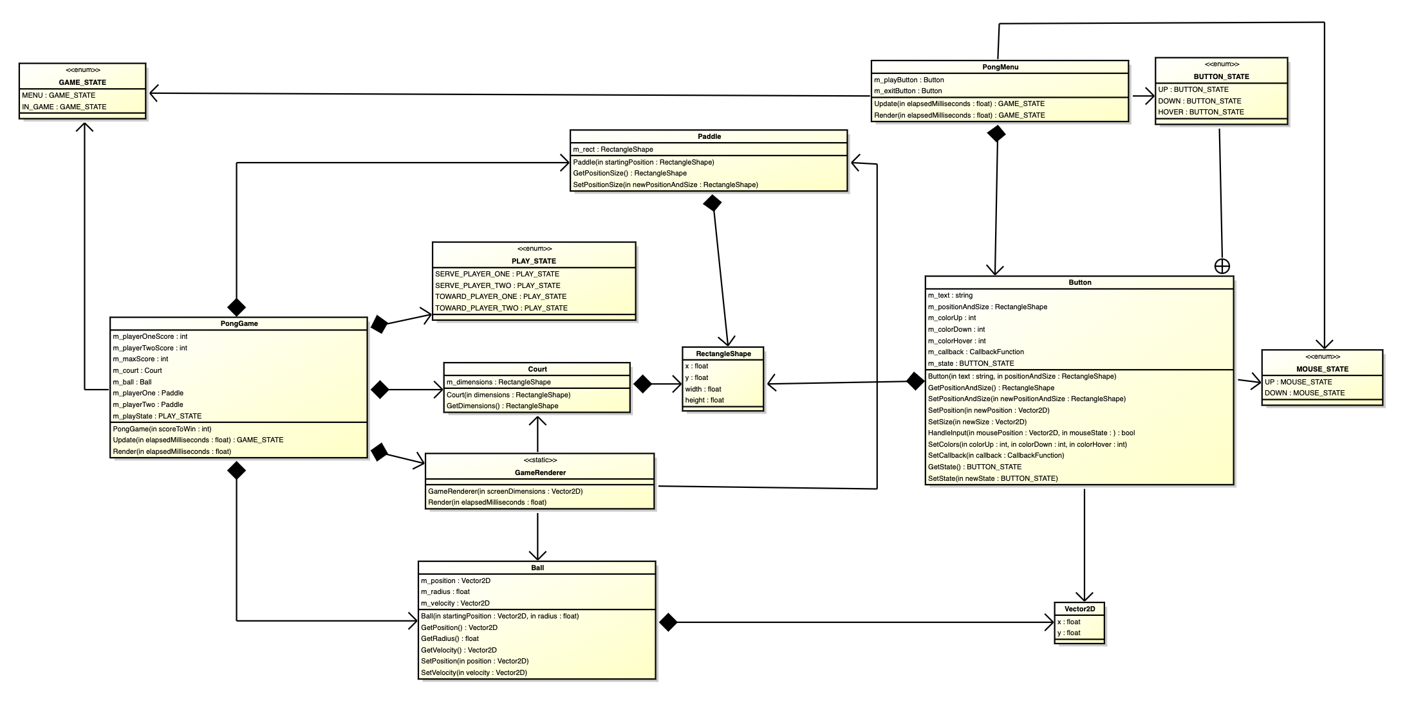

Samples:

